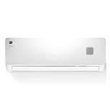

***Dawlance autoAir Conditioner***

* **Color:**white
* **Available:**in stock
* **Dimension:**1641*595*600
* **Size:**19
* **Old Price:**~~Rs41,22,999~~
* **New Price:**2,34,400 (5%)